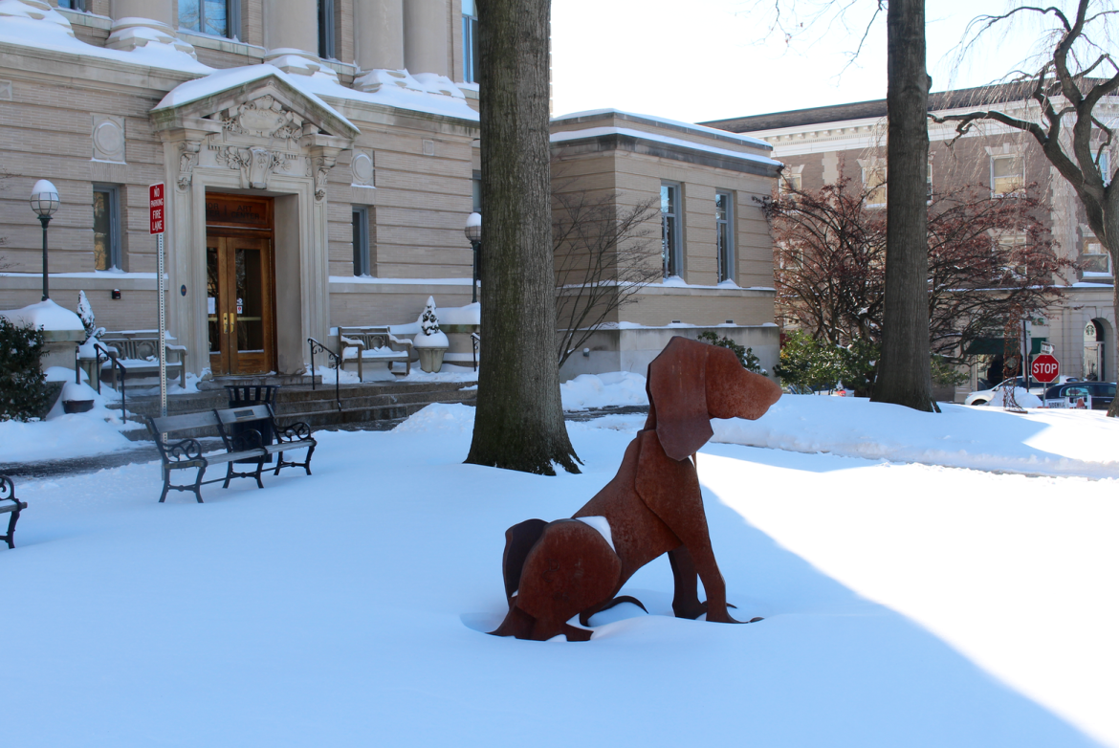

Updated Artist's Prospectus
Face Time 2019
Classic Techniques in a Digital Age

Open Juried Exhibition

January 13 - February 7, 2019

presented by
The Connecticut Society of Portrait Artists
www.csopa.org, csocietyopa@aol.com
and The Greenwich Arts Council

www.greenwichartscouncil.org, info@greenwicharts.org

BENDHEIM GALLERY

299 Greenwich Avenue 2nd Floor (with elevator), Greenwich, CT 06830

Sunday January 13: Meet the Masters Gallery Walk 2-2:30
Sunday January 13: Reception & Live Demo 2:30 - 4pm
(Snow date January 20)

JURORS: Wende Caporale and Grace DeVito
EVENT CO-CHAIRS: Michel Delafontaine and Jeanine Jackson

Image Above : The Greenwich Arts Council in Winter
ONLINE: DETAILS, PROSPECTUS, REGISTRATION LINKS
csopa.org/FT19.html

SUMBISSION FEES & PROCEDURES
(Online and Mail-In Requirements)

FT19 EXHIBITION ARTIST’S PROSPECTUS
DEADLINE December 7

Open Call for Portraits All portrait artists able to deliver or make shipping arrangements for delivery and pick-up of selected entries during specified date and times may submit. The Bendheim Gallery is located at 299 Greenwich Avenue, 2nd floor (with elevator), Greenwich CT 06830. CSOPA membership is not required to enter. Submission does not guarantee selection. Signed entry form is required to exhibit.

Jurors To be announced. Awards will be presented during the Reception January 12.

Works Eligible Original portrait paintings, drawings and sculptures not previously exhibited with CSOPA and completed within the past five years are eligible. No giclee, canvas transfers, photography or computer images. Paintings: must be framed and wired for hanging with size limit 60" (5') maximum horizontally, including frame. Gallery wrap may be accepted at the discretion of the curator. No easels. Sculpture: Limited to 75 lbs, 4' max across; moveable pedestals can be provided; base either integral or secured to piece. Sculpture questions may be directed to on request; Julia Murphy (toolmarkstudio@me.com). Sloppy pieces will be rejected at receiving. Artwork must be available from receiving through pick-up (January 5&6-February 7&8; See below).

*Submission Deadline and Procedure To be considered for selection for Face Time 2019, the following three requirements must be met by December 7, 2018:
#1 Signed Entry Form (regular mail only – form attached)
#2 Images (via email only: CSOPAentry@gmail.com – details below)
#3Payment by check with regular mail or by PayPal online click: Face Time 2019 (http://www.csopa.camp8.org/Default.aspx?pageId=72714) . Online payments preferred.

Up to 6 entries per artist.
*Join CSOPA visit CSOPA Membership ($40/year) or use form attached.
After September 30
CSOPA Members*: $35 first 2 submissions. $10 each additional
Non-Members: $40 first 2 submissions. $15 each additional

HOW TO SUBMIT IMAGES
Email JPEG Image(s): Email JPEGs of image(s) to CSOPAentry@gmail.com. JPEGs must be received by December 7 and in digital jpeg format only. Paintings and drawings: 1 image per portrait entry. Sculpture: minimum 4 images per entry - front, back, 3/4 left, 3/4 right; maximum 6 photos per sculpture. Resolution of at least 300 dpi is required plus and a minimum of 2,000 pixels vertically. Please make all JPEGS proportional to the original’s dimensions. Subject line should read “FT19-YourLastName” to ensure your email is received. Name each image attachment “YourLastName/PortraitTitle.” Please include the information below in the body of the email:
o Artist name
o Artist contact information (cell phone and mailing address)
o For each image: full title, height first x width in inches including frame, medium, date completed and price. If not for sale please indicate “NFS” and price for similar
Your effort to follow the electronic submissions specifications ensures the most advantageous representation of your work and allows CSOPA to make quality selections. Have questions regarding digital submissions? Email Michel Delafontaine mdelafon@optonline.net for technical help. Submission does not guarantee selection by CSOPA for the exhibit. Substitutions and late entries will not be accepted.

Notification A list of accepted works will be posted on the FT19 webpage on www.csopa.org by December 20, 2018. Selected artists will also be notified through the email you provide on the application.

FOR ACCEPTED WORKS
Selected artists will be asked to provide a paragraph for gallery labels about the "face-time" they experienced with the model or client. Please do not bring business cards, promotional materials, or portfolios for display. Referral information for each participating artist will be provided to visitors.
FT19 Digital Participation: The Bendheim Gallery and CSOPA may create QR Codes digital links to exhibiting artists. Please indicate on your registration form if you would like more information when available. Are you tech-savvy? If would like to volunteer to help with this project, write to Julia Murphy: toolmarkstudio@me.com
Receiving for Selected Artists: Receiving Saturday Jan 5, 1-4 & Sun Jan 6, 12-3 Artwork must be delivered, unpacked and ready for hanging or display. Gallery wrap may be accepted at the discretion of the curator. Sloppy pieces will be rejected at receiving. If using a shipper, they must be responsible for delivery, uncrating, pick-up, and packing. Neither CSOPA volunteers nor the gallery will unpack/pack portraits. Questions regarding receiving or pickup may be directed to Michel: mdelfon@optonline.net.
Removal: Pickup Thursday February 7, 3-7pm & Friday February 8, 9am-2pm All art MUST be picked up during these times. Works not removed at this time will be charged $20/day storage fee and stored at the artist's own risk. Neither CSOPA nor The Greenwich Arts Council will be held responsible for loss or damage to artwork from time of delivery until pickup. In the event of inclement weather, snow dates will be announced via email.
Prizes for First, Second and Third place artwork. Sponsor Gifts, Ribbons for Honorable Mention and Certificates of Merit also awarded at the Jurors’ discretion. Commissions: Art for sale during the exhibit is encouraged. Bendheim Gallery commission is 30% of pre-tax sale price during the exhibition and up to three months after. In support of our programs, a 10% donation to CSOPA is expected on sales resulting from this exhibition.
Liability: The GAC insures individual artworks up to $500 per item while on view. Beyond that, neither CSOPA nor The Greenwich Arts Council or their agents can be held responsible for loss or damage to artwork however caused. Your entry to this exhibition constitutes your agreement with these terms and conditions. Selected artists may opt to have their own insurance.

FACE TIME SUBMISSION FORM (Completed and Signed Form Required) “CSOPA” c/o CSOPA President, Jeanine Jackson, 3 Wescott Court, Riverside, CT 06878 (max. 6 entries total) or scan and email to csocietyopa@aol.com
Artist’s Full Name _________________________________________________________________
Street Address; Town, State, Zip
________________________________________________________________
Cell Phone Email
After September 30 (Deadline December 7)
Where did you hear about FT19? (optional)
Website:___________________
Facebook: ____
Instagram:____
Twitter:______
Other:_____________________

First 2 Entries CSOPA Member* $35 $ ________
Additional Entries CSOPA Member @ $10 each $________
First 2 Entries NonMember $40 $________
Additional Entries NonMember @ $15 each $________
*Active CSOPA Membership is required for member rates. Register/Renew/Update Go to: http://www.csopa.camp8.org.
or Join/Renew your CSOPA membership now @$40/year $ ______
I wish to donate to this show in the amount of $_______
My name may be listed as a CSOPA Patron (Yes/No) ______

Paid with PayPal on csopa.camp8.org $__________ or Check Amount Enclosed Payable to “CSOPA” $ __________

If selected, please indicated your interest in receiving FT19 Digital Participation info. (Yes/No) ______
CSOPA, The Greenwich Arts Council and their agents cannot be held responsible for loss or damage to artwork however caused. Your entry to this exhibition constitutes your agreement with these terms and conditions. I hereby agree to the liability clause and to abide by the rules of this prospectus for the CSOPA Face Time 2019 Exhibit.

Artist's Signature Date
Optional Release: I hereby give CSOPA, The Greenwich Arts Council or their assigns permission to use my submitted artwork and my name for promotional purposes and to post my artwork on the CSOPA and GAC websites.

Artist's Signature Date

